**UML CLASS DIAGRAM**

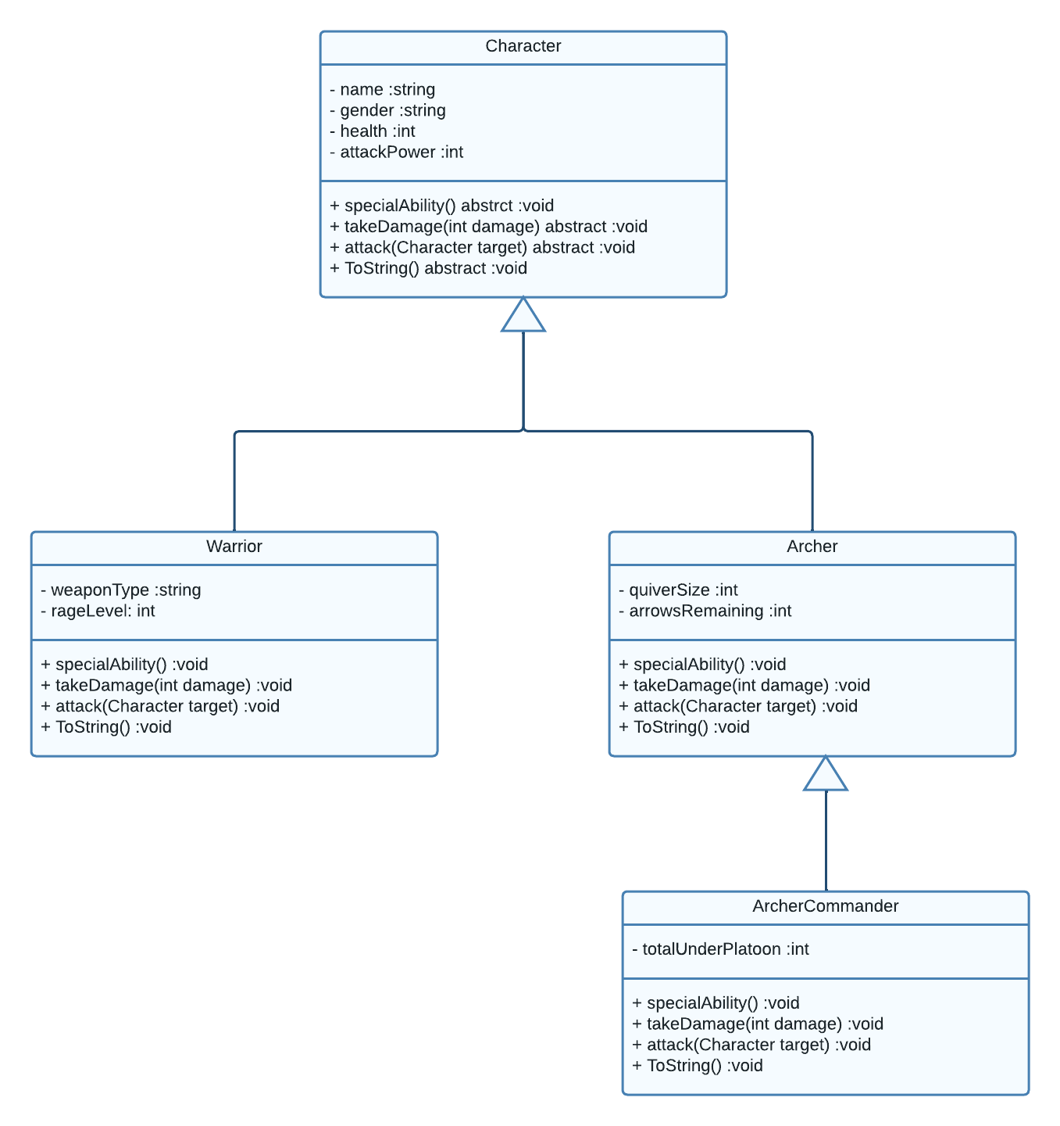

**Sorting Algorithm Comparison Charts**

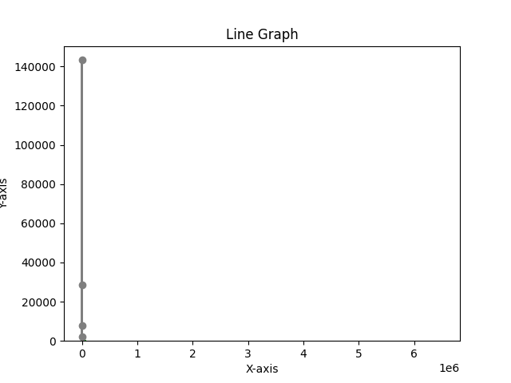

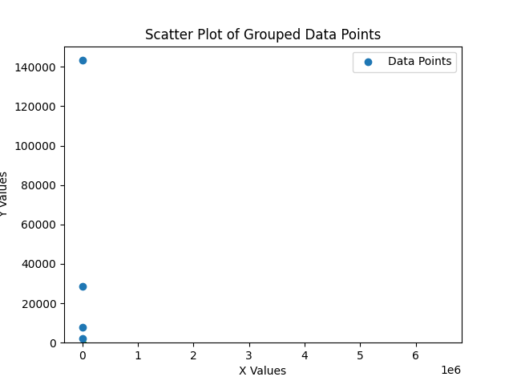

As we can see from the above results quick sort performs 7800 swap operations, Insertion sort perform 143307 swap operations, Merge sort performs 2068 comparison operations, Selection sort performs 28680 swap operations.

So here complexity of Quick sort is **O(n(log n)),** Merge Sort is **O(n(log n)),** Selection sort is **O($n^{2}$),** Insertion sort is **O($n^{2}$)**

**Unit Testing**

In this unit testing we are testing attack function of both game characters. Initially both powers are displayed.



Now this Screen shot is taken when Warrior put 2 attacks on Archer with attack power of 30

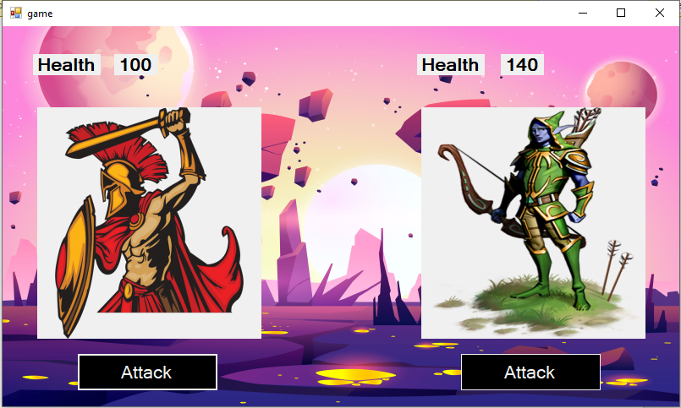

Now after Archer died Warrior cannot hit Archer game character back as its power is already 0



So, the minimum power of both characters can be 0 i.e if they are dead.